**REPORT FOR MALL CUSTOMER (CUSTOMER BEHAVIOUR)**

The purpose of this analysis is to understand the customers of this client and those that can be easily converged so as to help the marketing team plan strategically on ways to converge such customers.

From the analysis conducted using the KMeans Clustering Algorithm, an Unsupervised Machine Learning technique, the customers were classified into 5 groups based on their age and spending score as well as their income and spending score.

The spending score was assigned to each customers based on defined parameters like customer behaviour and purchasing data.

From the graph below, we can conclude that Customers in cluster 0 have a low income but their spending score is very high. Certain product recommendation can be given to such customers, discounts can also be given to such customers so that they can visit the mall again i.e to retain them

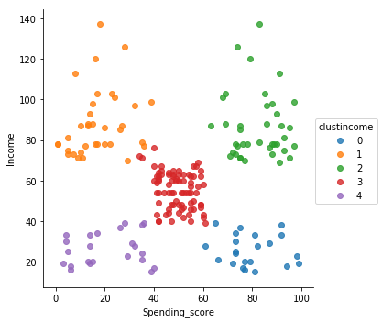

Customers in the cluster 1 have a high income but their spending score is relatively low compared to their income level. Such customers should be targeted and should be recommended with products appealing to them to improve their spending score .

Customers in cluster 2 have a high income and are already spending much.

Customers in cluster 3 have the same income as their spending scores. Coupons can be given to such customers so as to improve their spending score.

Customers belonging to cluster 4 have a low income with spending score below average.

In conclusion, the marketing team should target such customers belonging to clusters 0,1 and 3 to boost revenue for the company.